
PT1/GEQP/1223/A 25-APR-2023
PERIODIC TEST - I (2023-24)
Subject: GEOGRAPHY  Grade: XII |  |  | Max. Marks: 35  Time: 80 Minutes
General Instructions:
I. Question paper is divided into A ,B,C,D&E

II .In section A question number 1 to 5 are Multiple Choice Questions

III. . In section C question is Source based question
IV .In section D questions are Short Answer based questions.
V. In section E questions are Long Answer based questions.

VI .In section F question is a Map based question.
SECTION A
Multiple Choice Questions
1. | Which of the following is not an approach in human geography? |  |  |  |  | 1
 | (A) Areal differentiation |  |  | (C) Quantitative differentiation
 | (B) Spatial differentiation |  |  | (D) Exploration differentiation
2 | Behavioural School of Thought laid emphasis on: |  |  |  |  | 1
 | (A) past experience |  |  | (C) present experience
 | (B) live experience |  |  | (D) None of the above
3. | Neo- determinism was introduced by: |  |  |  |  | 1
 | (A) Marx |  |  | (C) Griffith Taylor
 | (B) Newton |  |  | (D) Mahatma Gandhi
4. | _________ refers to the way in which the population is spaced out all over the world. |  |  |  |  | 1
 | (A) Density of population |  |  | (C) Population distribution
 | (B) Population distribution |  |  | (D) Population explosion
5 | Arrange the following phases in a sequence order according to their occurrence in Indian population:  (i) Population explosion  (ii) Stationary phase  (iii) Decreased growth  (iv) Steady growth |  |  |  |  | 1
 | (A) i, iv, ii, iii |  |  | (C) ii, iv, i, iii
 | (B) iv, i, iii, ii |  |  | (D) iii, ii, iv, i
SECTION B
Source Based Question
6 | Read the case study given below and answer the questions that follow: Growth of population is the change in the number of people living in a particular area between two points of time. Its rate is expressed in percentage. Population growth has two components namely; natural and induced. While the natural growth is analysed by assessing the crude birth and death rates, the induced components are explained by the volume of inward and outward movement of people in any given area. The decadal and annual growth rates of population in India are both very high and steadily increasing over time. The annual growth rate of India’s population is 1.64 percent (2011). The growth rate of population in India over the last one century has been caused by annual birth rate and death rate and rate of migration and thereby shows different trends. |  |  |  |  | 3
6.1. | How is the growth of population expressed?
6.2. | Define natural growth of population.
6.3. | What was the annual growth rate of India as per 2011 Census?
SECTION C
Short Answers
7. | Bring about any three differences between Determinism and Possibilism. |  |  |  |  | 3
8. | Explain with examples the three economic factors influencing the population distribution in the world. |  |  |  |  | 3
9. | Interpret and briefly explain the three stages of Demographical Transition Theory. |  |  |  |  | 3
 | 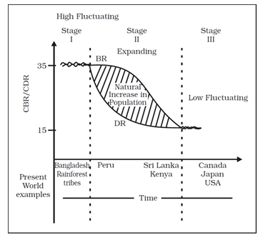
10 | Define ‘Human Geography’. What are the two approaches of Geography? |  |  |  |  | 3
11. | Name any three Indian Linguistic families and give examples of each family. |  |  |  |  | 3
SECTION D
Long Answers
12. | Describe important features of the concept of Natualisation of Humans |  |  |  |  | 5
13. | Explain the characteristics of the growth of population in India |  |  |  |  | 5
SECTION E
Map Question
14 | On the given outline map of India mark the following: |  |  |  |  | 2
1. | State with highest population density (2011)
2. | State with lowest population density (2011)
Name: |  | Class/Section: |  |  | Roll No:
